|  |
| --- |
| [2014][UD5] |
| Magic tactil - |
| Magic Tactil is a game on tablet and PC for playing trading card games. The player would be able to trade cards, have fun with friends but also participate in the life of an international community. So the user would discuss on our forums and be able to organize events. |

21/03/2013

INTRODUCTION

The project consists of a platform based on the card game Magic: The Gathering. This application would allow users to play the game as in real life. The application will be available on IOS, Surface, Pixel Sense, Windows 8 as well as Android. This paper is intended to provide explanations about this platform and so guide the user when to use it.

Document description

|  |  |
| --- | --- |
|  |  |
| Title | [2014][UD5] |
| Date | 21/03/2013 |
| Auteur | Oualid JOUHRI/Mehdi FARSI |
| Email | [magictactil@epitech.eu](mailto:magictactil@epitech.eu) |
| Version | 6.0 |

Revision table

|  |  |  |  |  |
| --- | --- | --- | --- | --- |
| Date | Author | Section(s) | Comment |  |
| 21/03/2013 | Jouhri_o/farsi_m | All | First revision |  |
| 20/05/2013 | Periph_a | All | About Windows Client |  |
| 27/05/2013 | Periph_a | All | About Android and IOS |  |
| 18/07/2013 | Periph_a | Utilization | Rooms |  |
| 24/11/2013 | Periph_a | Deck,Game | Screenshots  About windows |  |

Summary

Install & uninstall 6

Android 6

Install the application 6

Uninstaller the application 6

Windows 7

Install app 7

Uninstall the application 7

IOS 8

Install the application 8

Uninstall the application 8

Utilization 10

Authentication 10

Account creation 10

Sign In 12

Logout 14

Profile 15

Editing personal information 15

Event 18

Create an event 19

Participate in an event 22

Friends 22

Add a friend 22

Remove a friend 26

Room 26

Create a room 26

Join a room 26

Leave a room 27

Deck Building 28

Create a new deck 28

Modify an existing deck 29

Game 30

Message an opponent 30

Move cards 30

Contact 31

# Install & uninstall

## Android

### Install the application



1. Open **Google play** and locate the app **Magic Tactil**. After, push installation button.

### Uninstaller the application

1. Click on **Option =>Settings**
2. Go to apps
3. Select **Manage appplication**

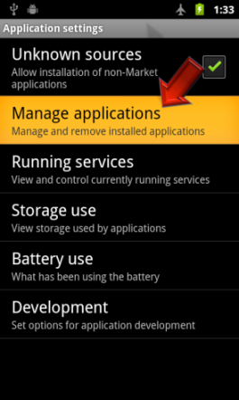

1. Select **Magic tactil** in the list
2. Click on **Uninstall**

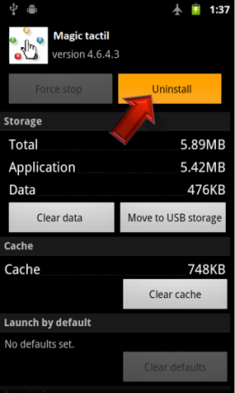

## Windows

### Install app

On Start screen, open Windows Store.



Find app **Magic tactil**. Click on "**Install**".

After installation, the start screen will display the app.

### Uninstall the application

Find app **Magic tactil** by using the **Finder**.

Select app and click on Uninstall button.



Click on "**Uninstall**".

## IOS

### Install the application



Open **App Store** on iPhone and locate app **Magic tactil**. After, push on **Install button**.

### Uninstall the application

1. Push and maintain click on Magic tactil app icon on Home screen until icons start to shake.

2. Press on the "x" in the corner of the application you want to delete.



3. Push on Delete to delete all data of the app.

4. Click on Home **button** to cancel the deletion.

# Utilization

## Authentication

### Account creation

To create an account it is mandatory to fill in the following fields:

* + - User name
    - Email
    - password

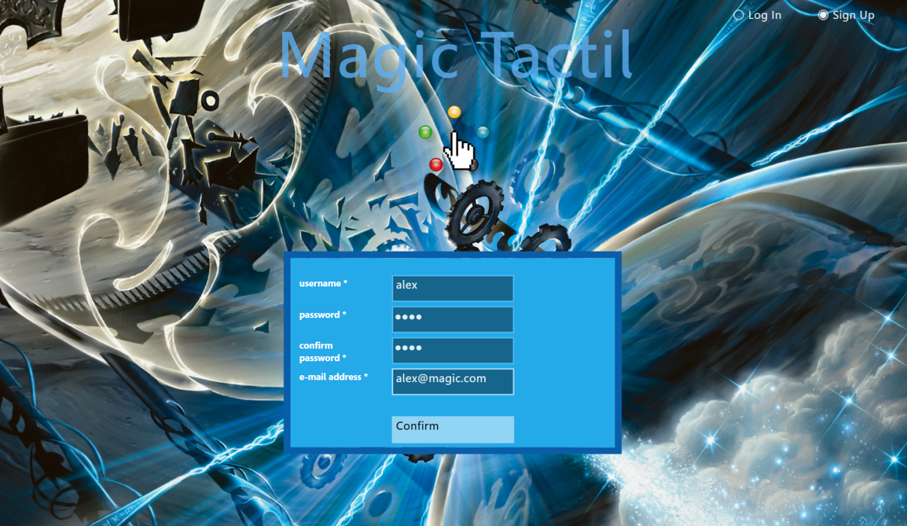

* 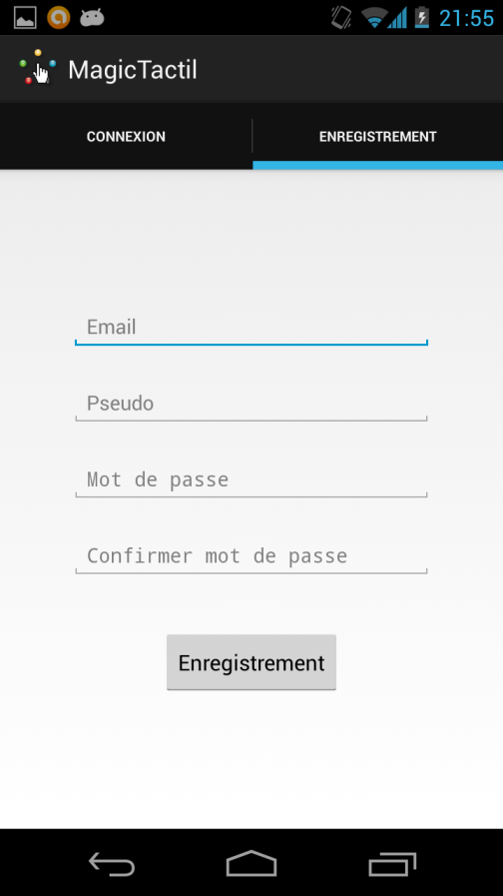
* 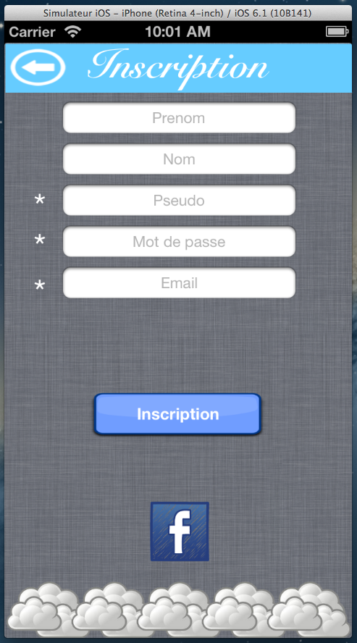

### Sign In

To log in the user needs to fill in the following fields:

* + - Username
    - password

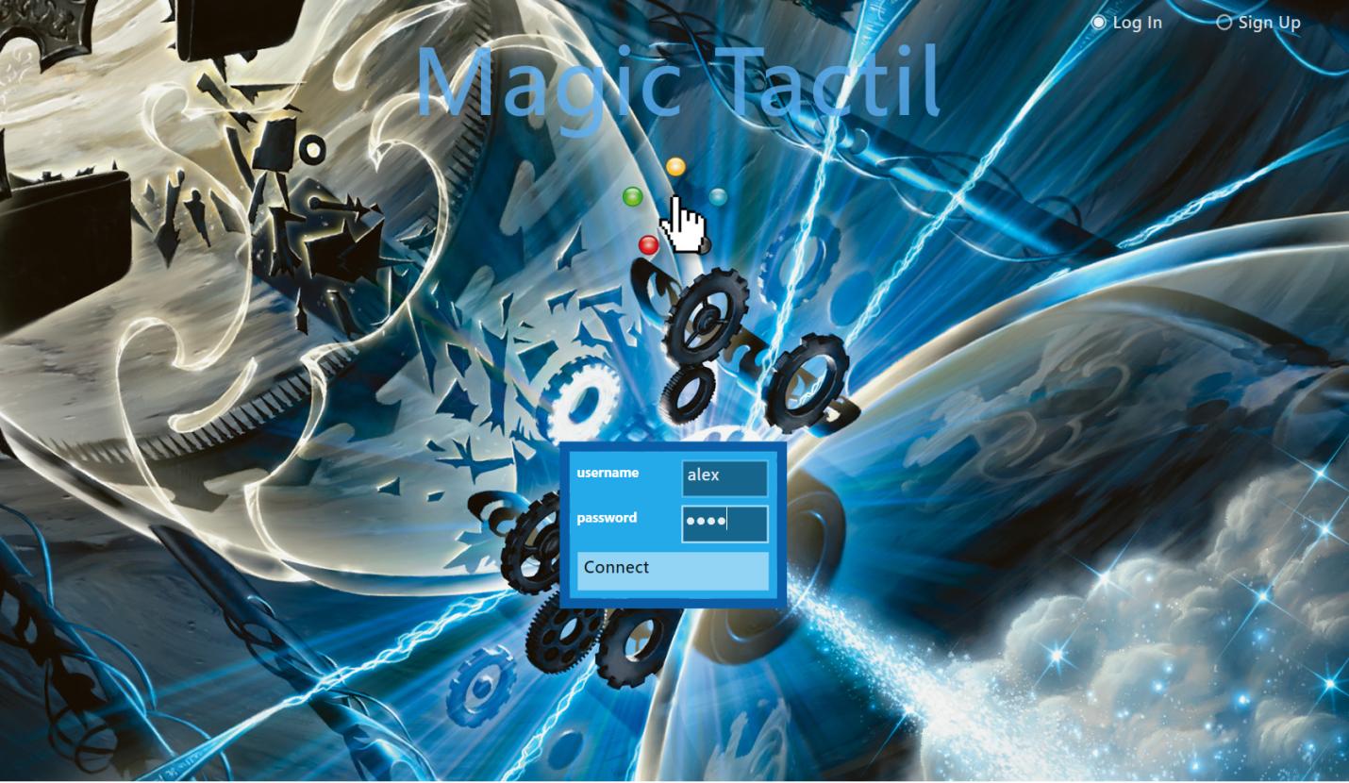

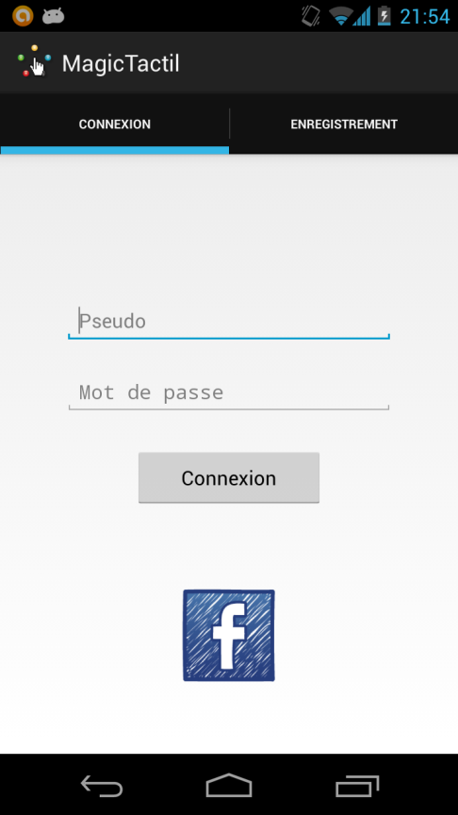

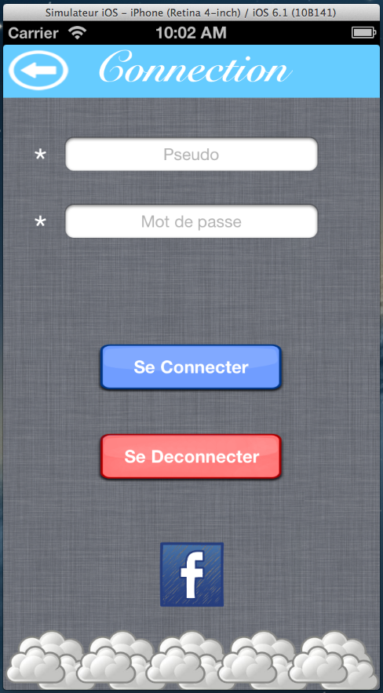

### Logout

To log out the user needs to open tab **Settings** and click on « **Log out** ».

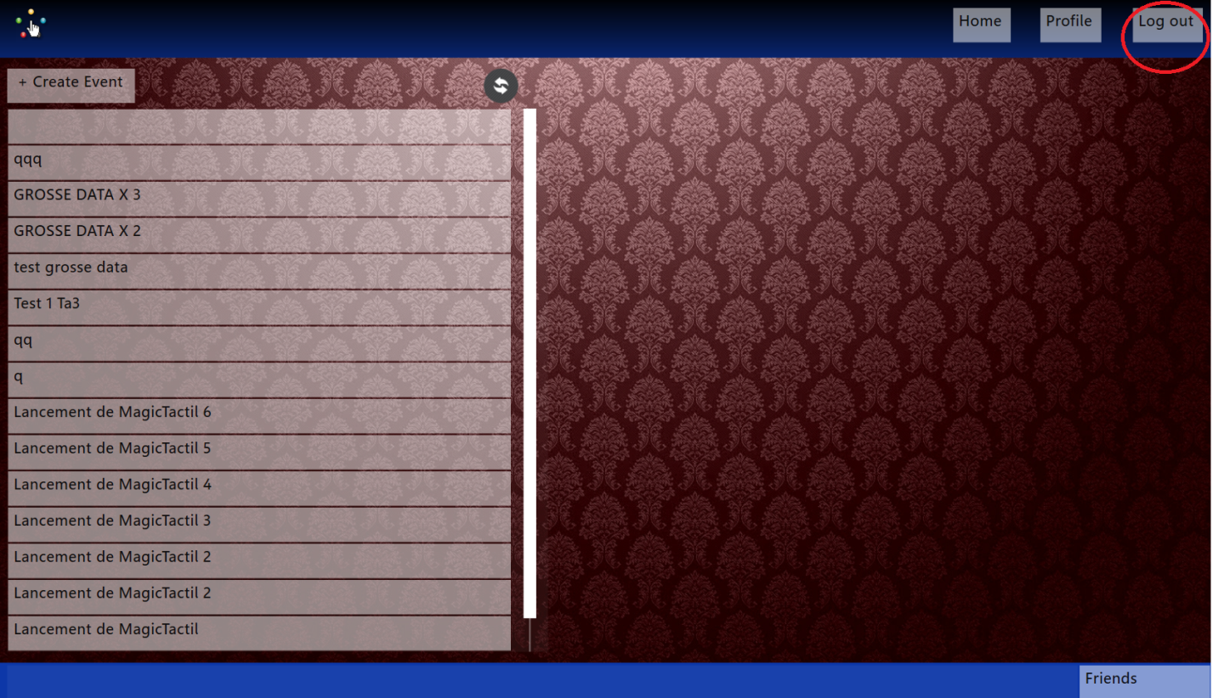

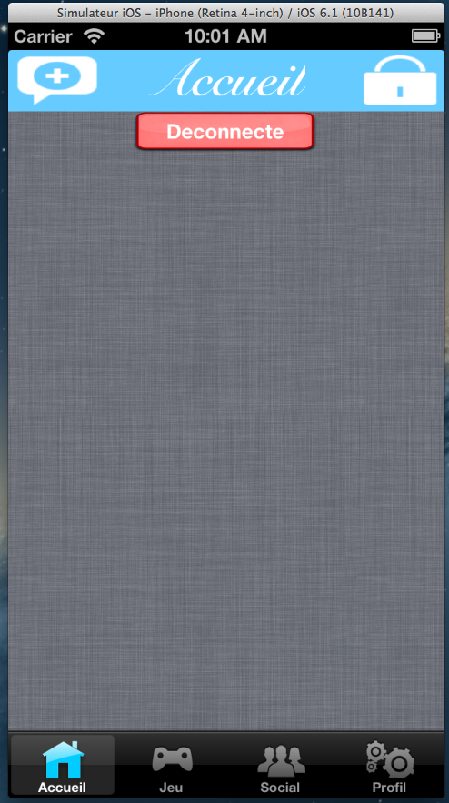

## Profile

### Editing personal information

To edit personal information you just replace them through the application.

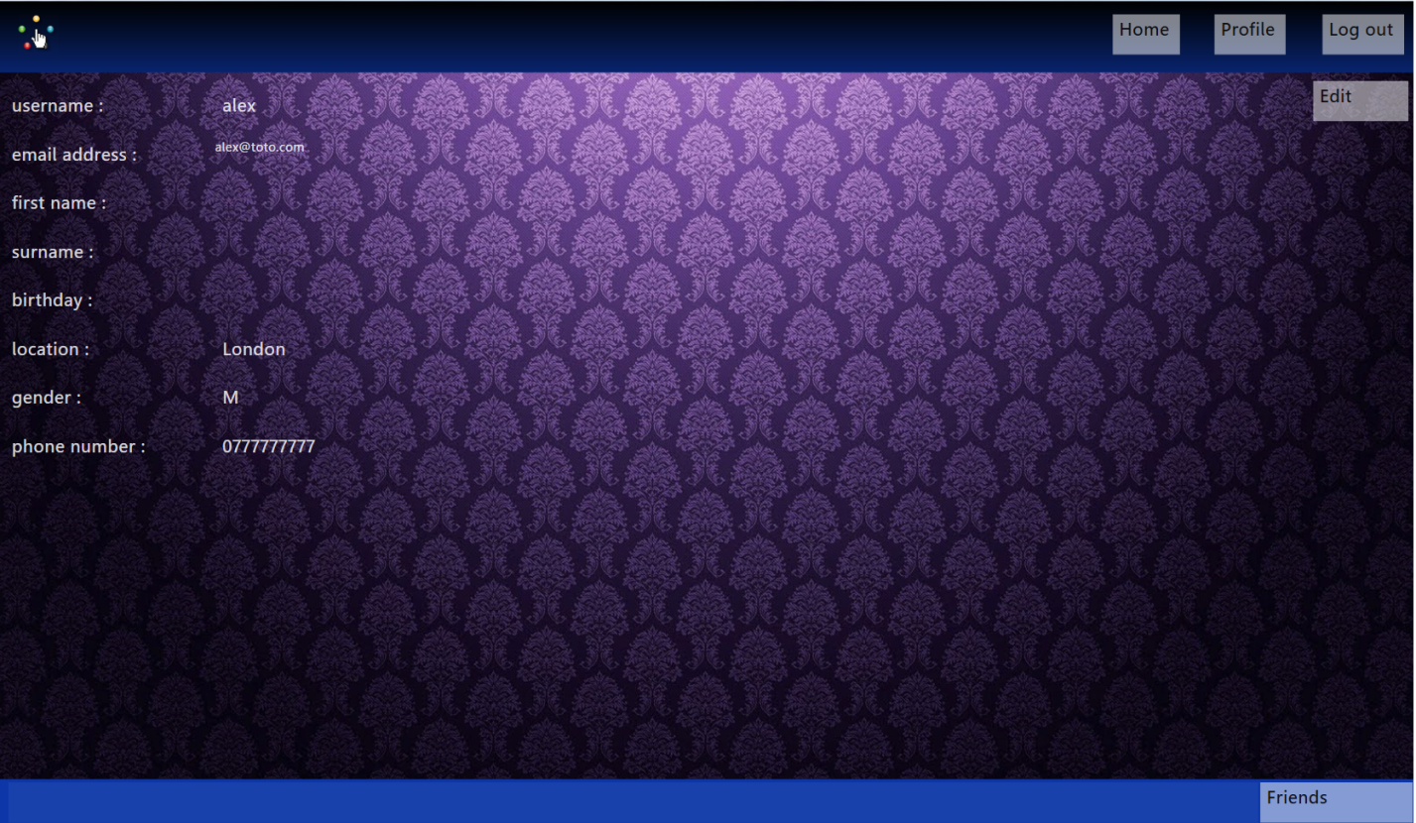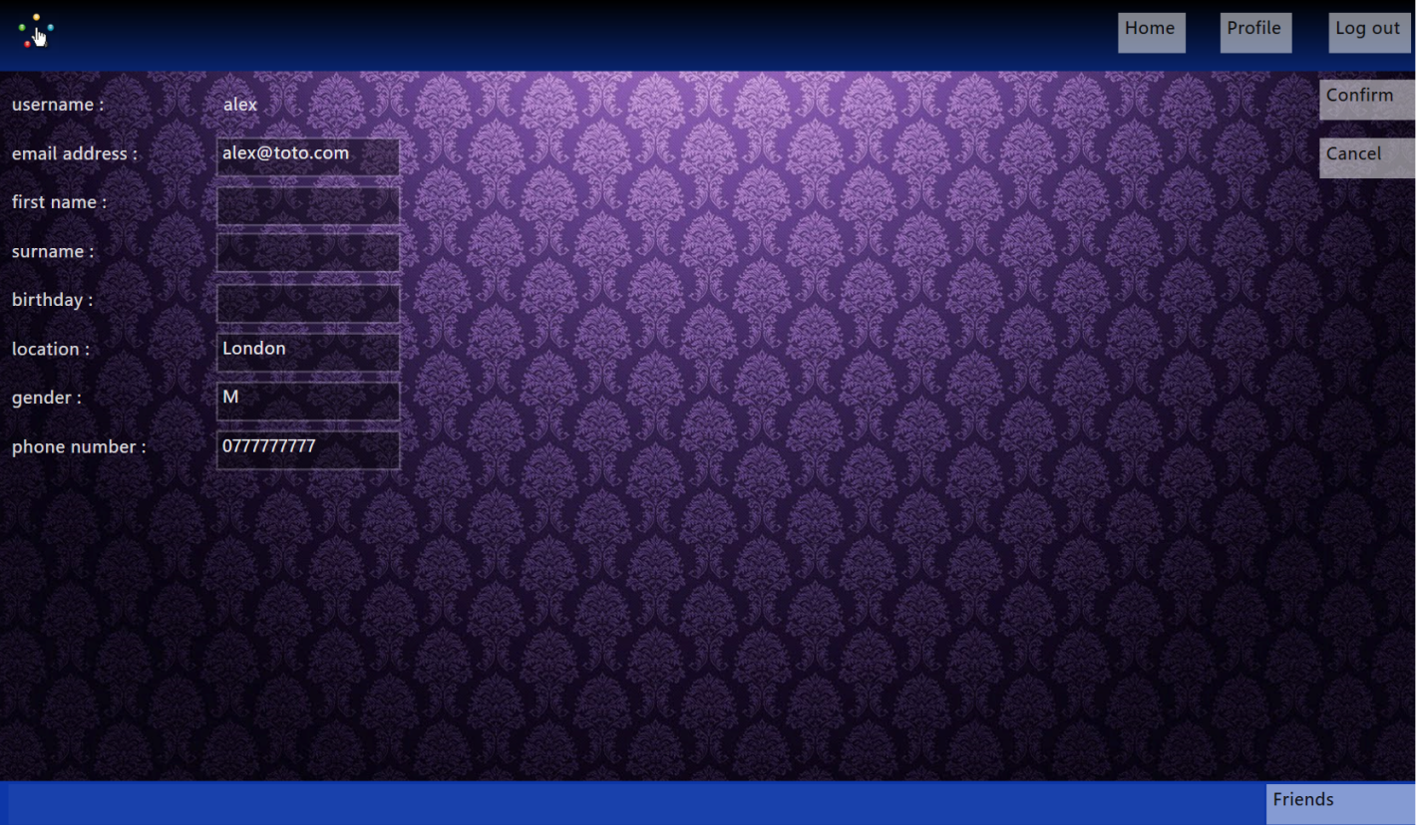

 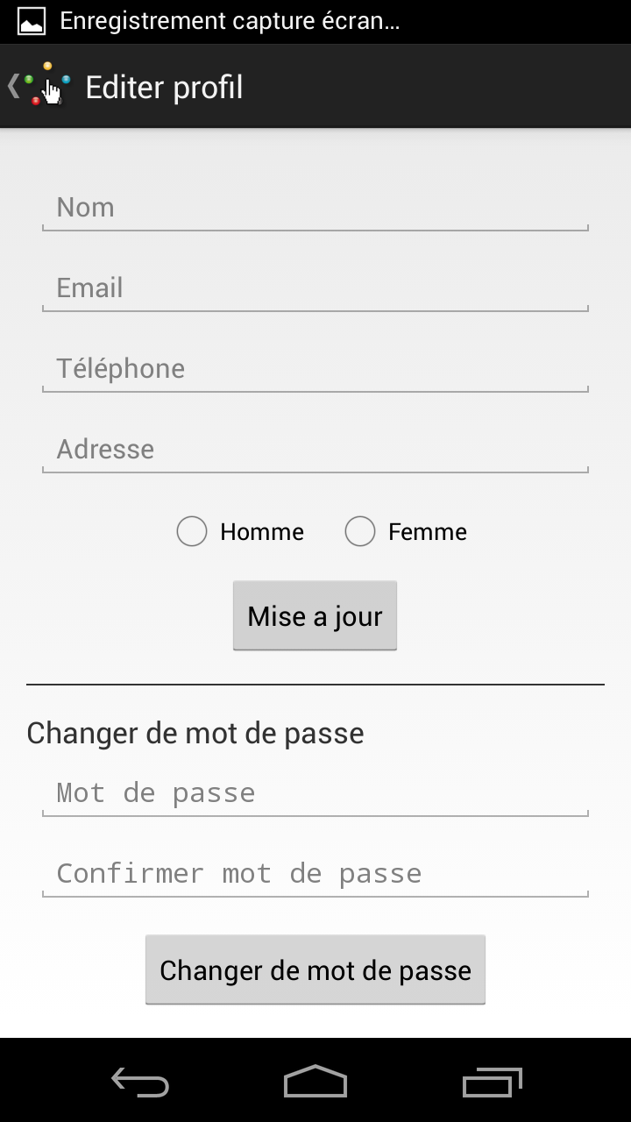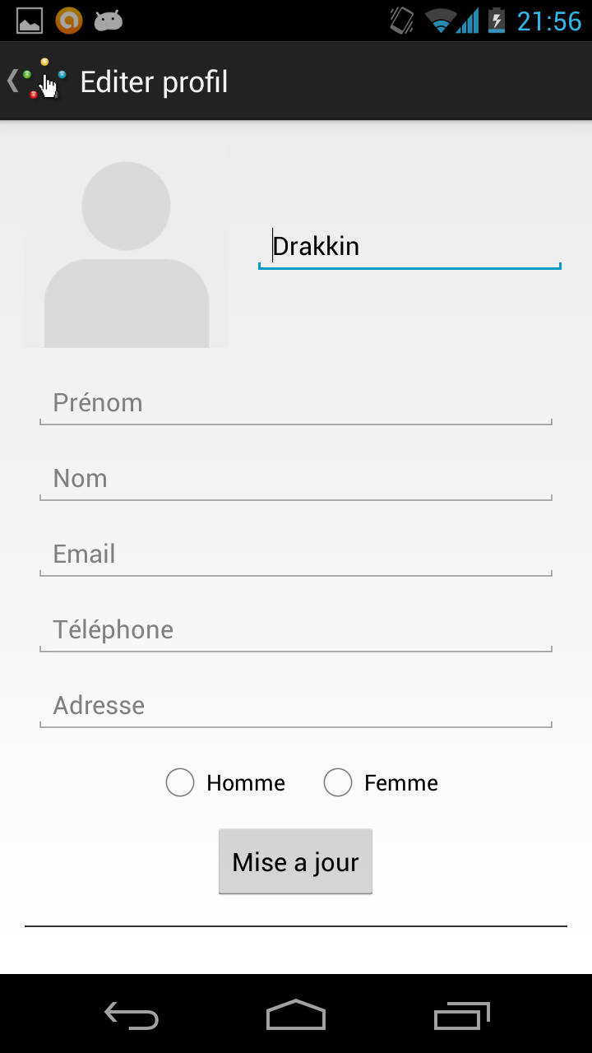

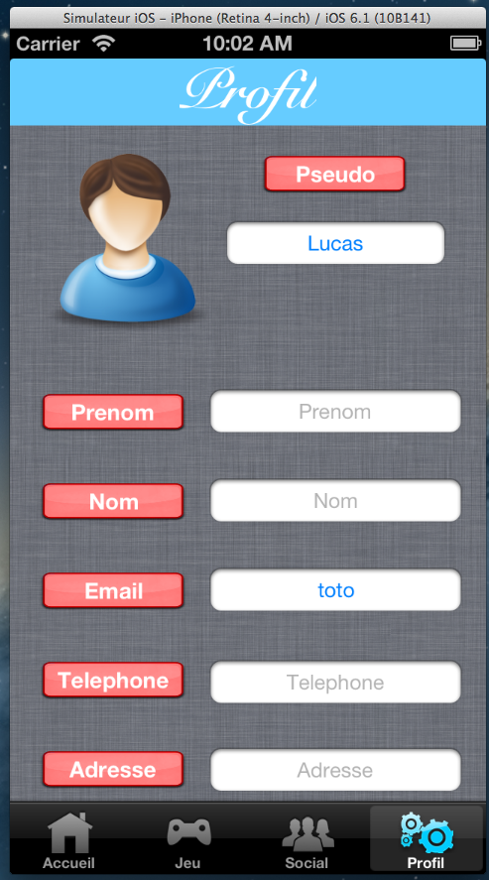 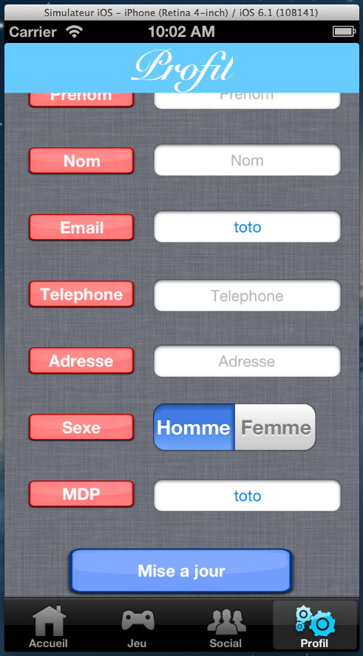

## Event

### Create an event

To create an event the user needs to open tab **Events** and click on **Create an event**. After, just fill in the following fields:

* Title
* Date
* Description

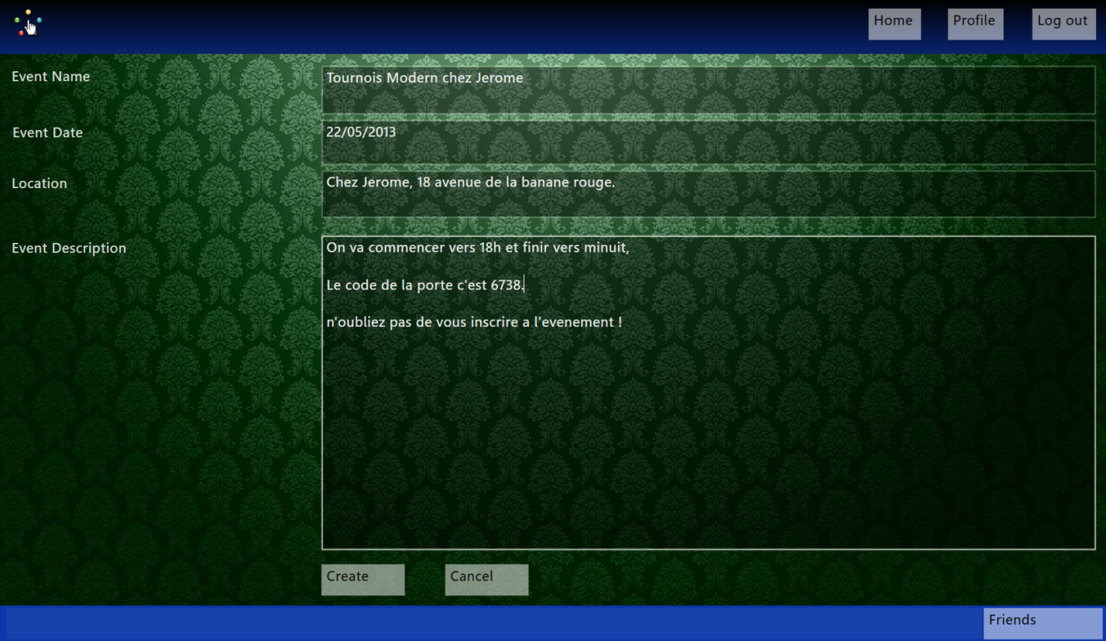

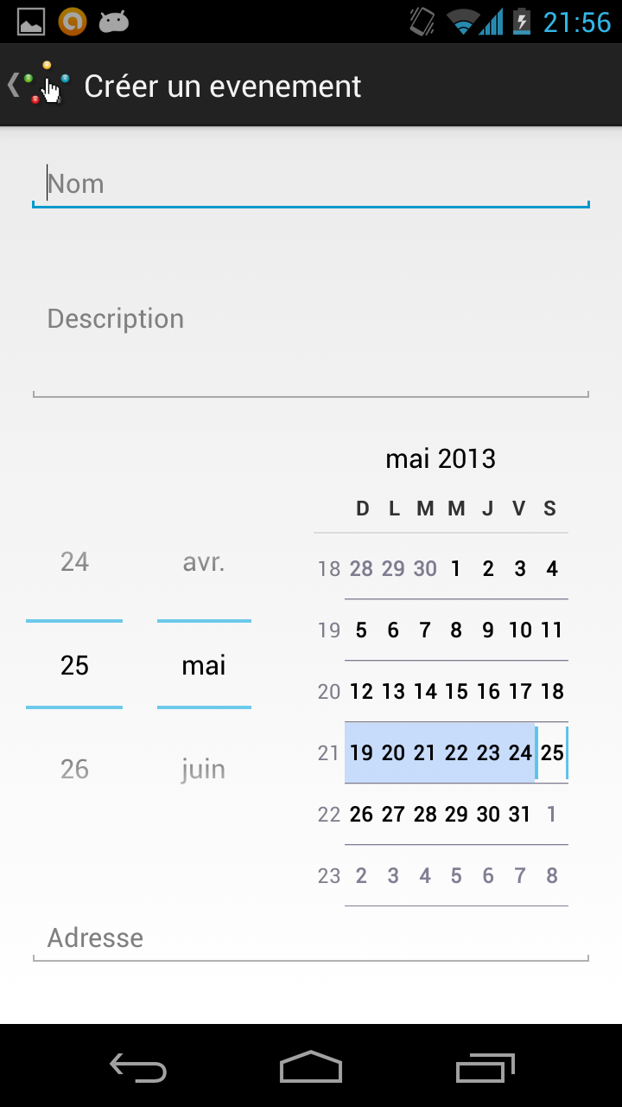 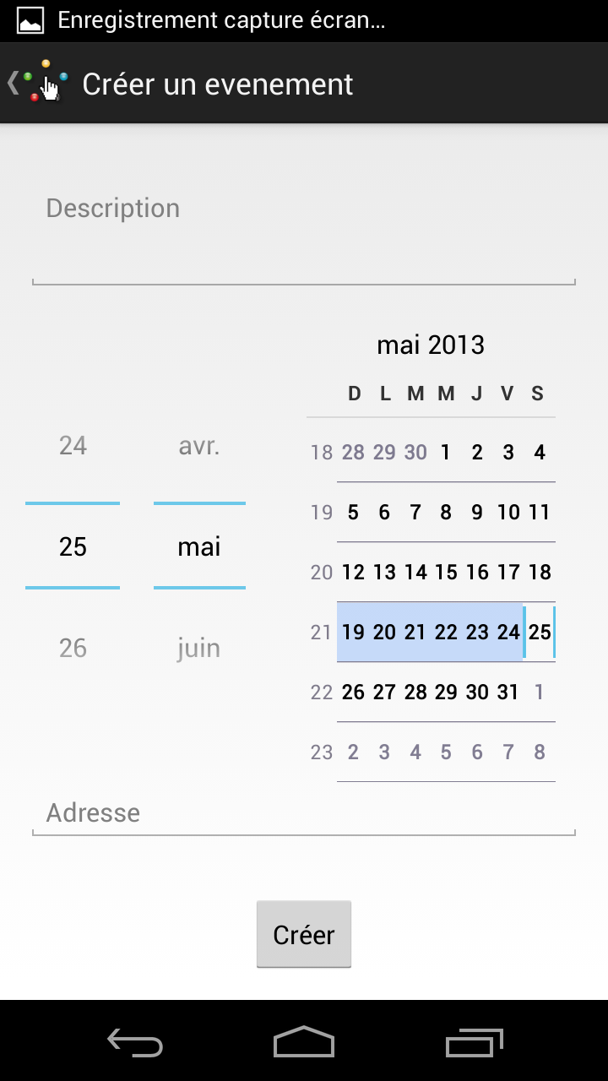

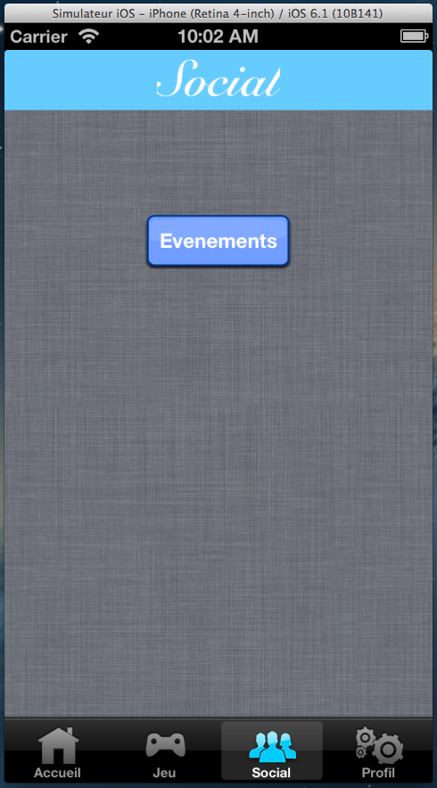

### Participate in an event

To participate in an event the user needs to open tab **Events**, select **Events list** and pick an event on the list. After, just click on **I participate.**

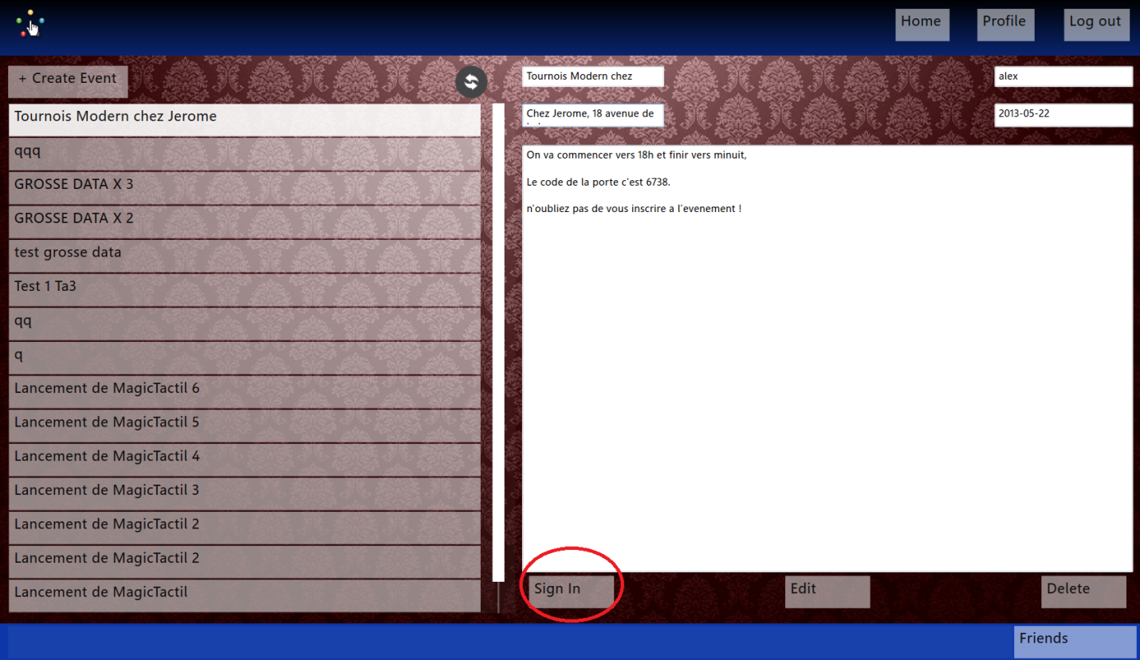

## Friends

### Add a friend

To add a friend the user needs to open tab Friend and select **add friend**. After, fill in the field **Name**.

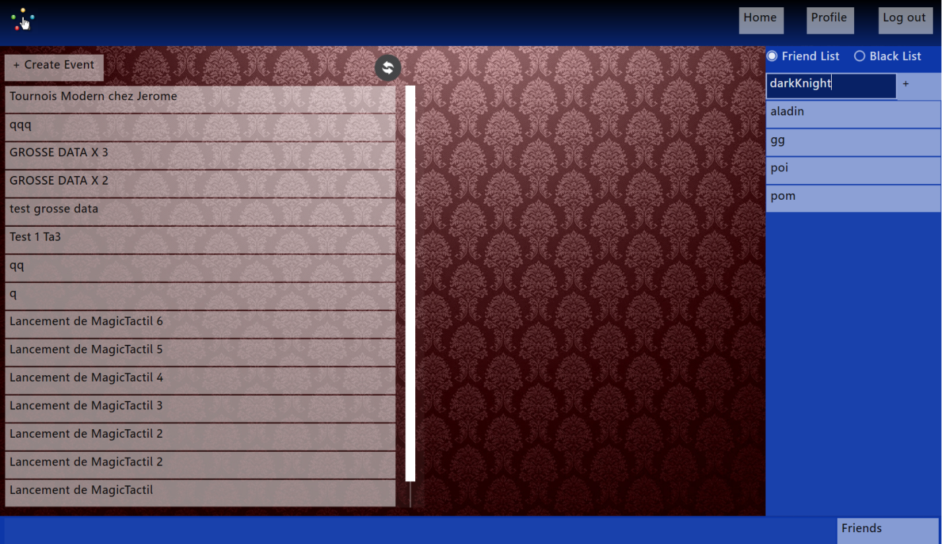

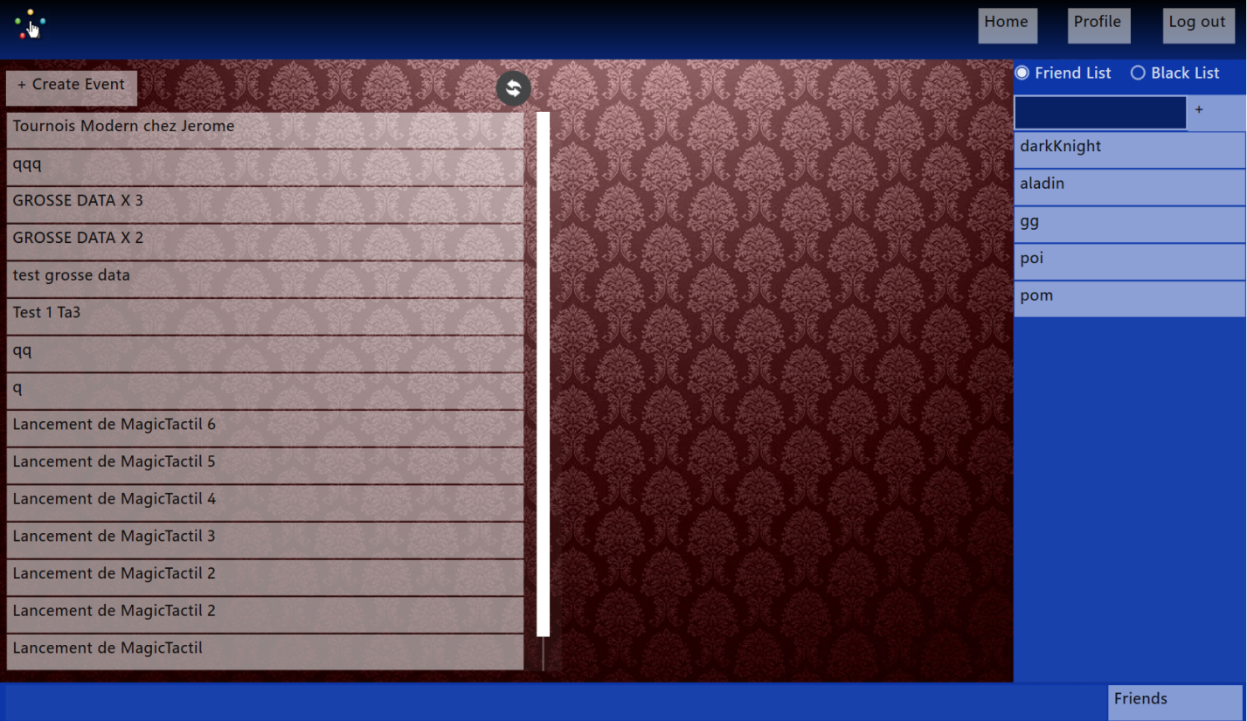

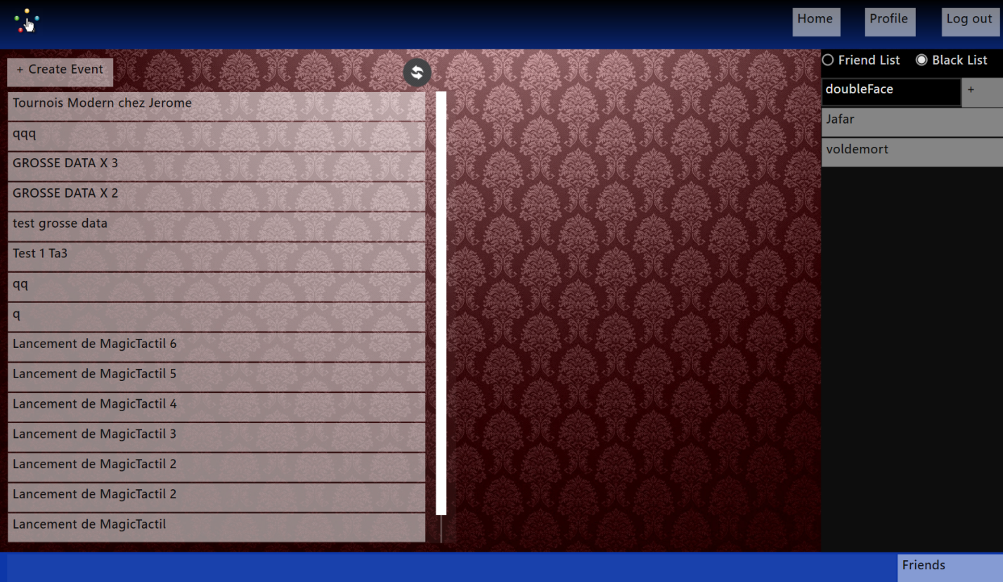

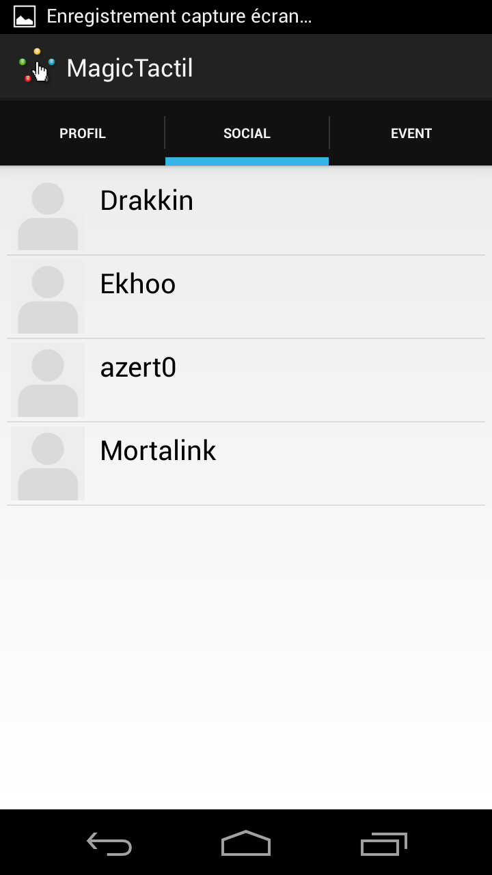

### Remove a friend

To remove a friend the user needs to open tab Friend and select **Friend list**, pick a friend and maintain a long click on this friend. A menu is displayed. On this menu, the user select **Remove**.

## Room

### Create a room

To create a room the user needs to fill in the following fields:

* + - Maximum number of players
    - Format
    - Nom de la room

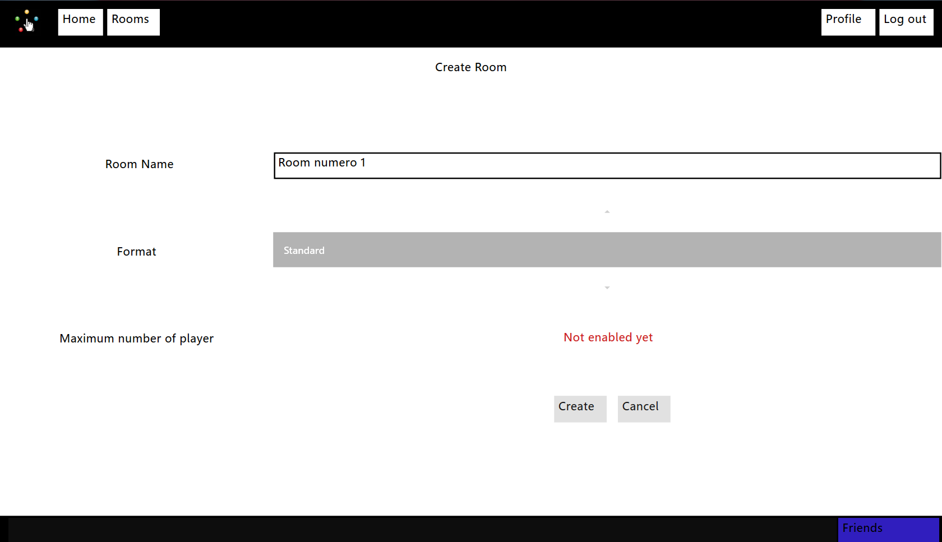

### Join a room

To join a room the user just has to select it from the room list.

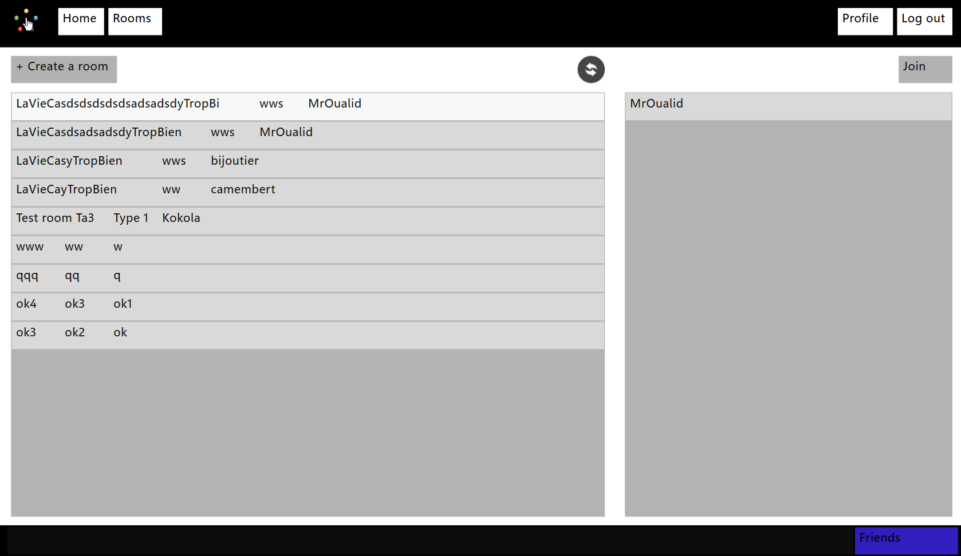

### Leave a room

To leave a room, just push the leave button.

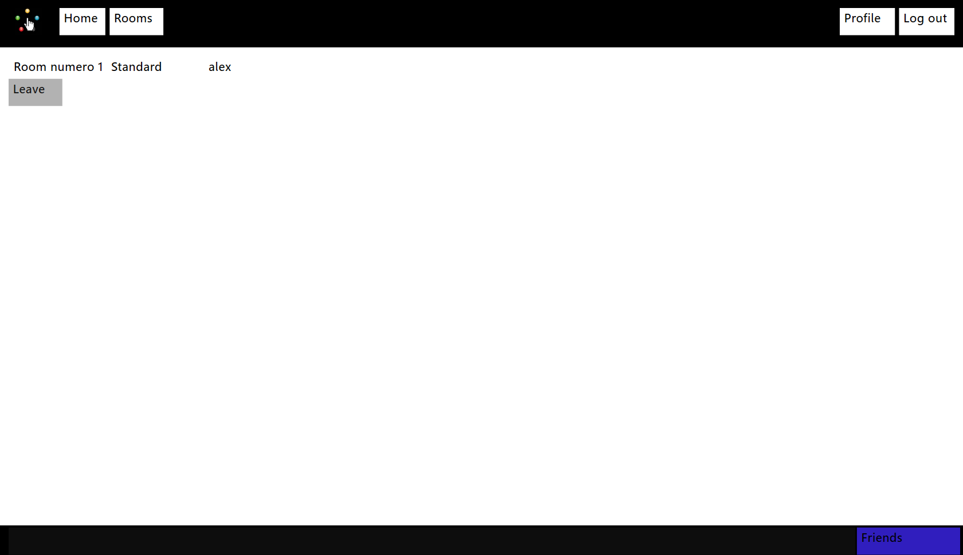

## Deck Building

### Create a new deck

Through the deck interface click the New button:

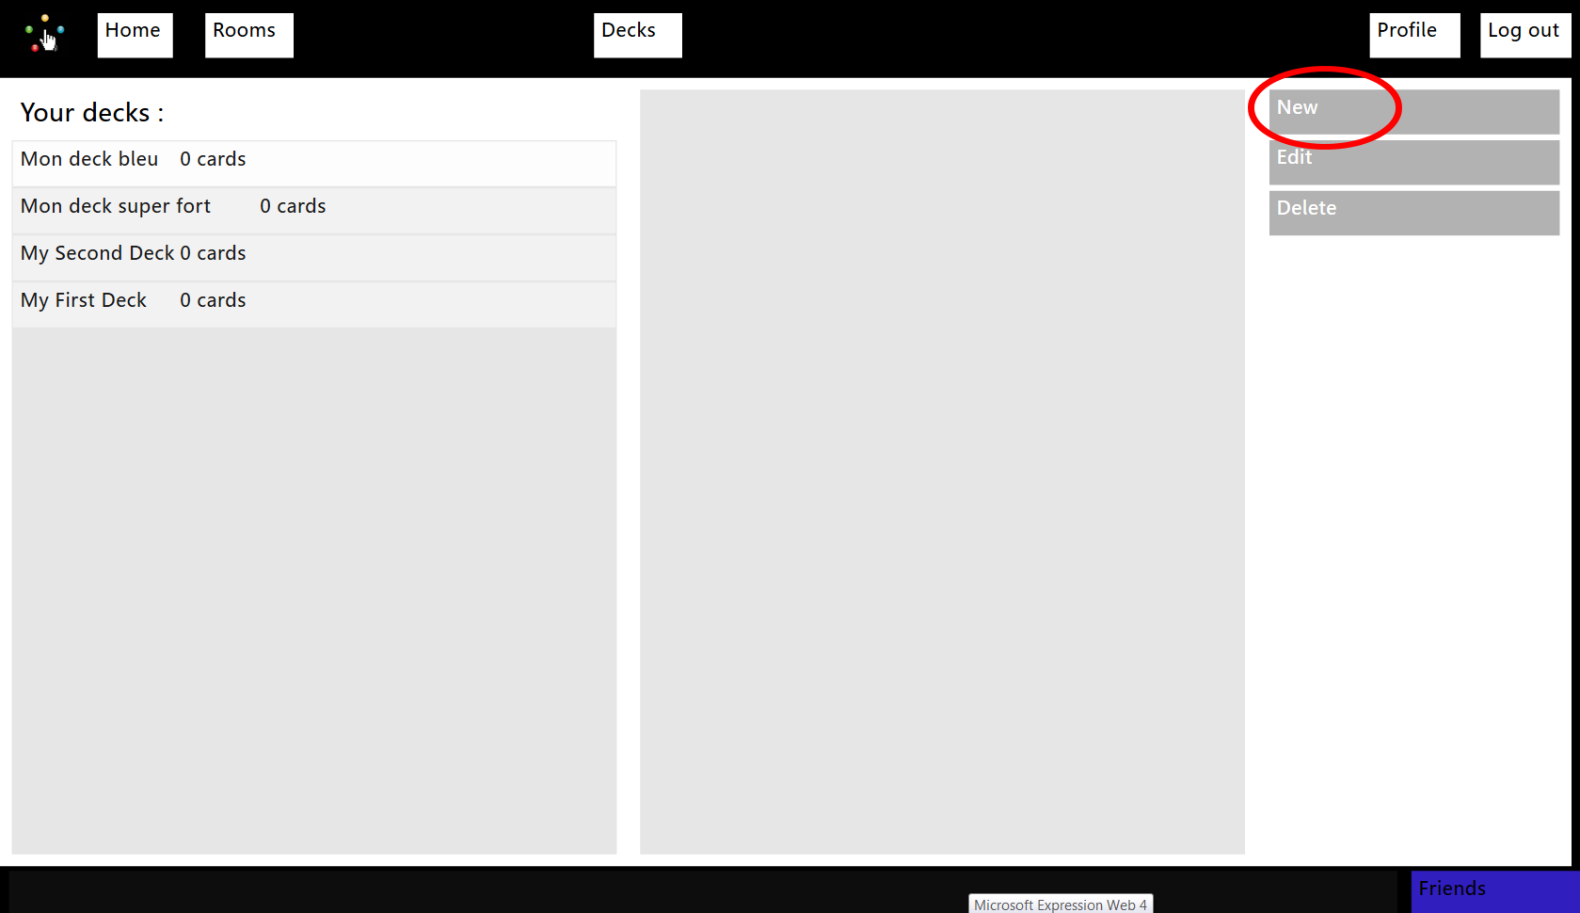

It will lead you to the deck building interface:

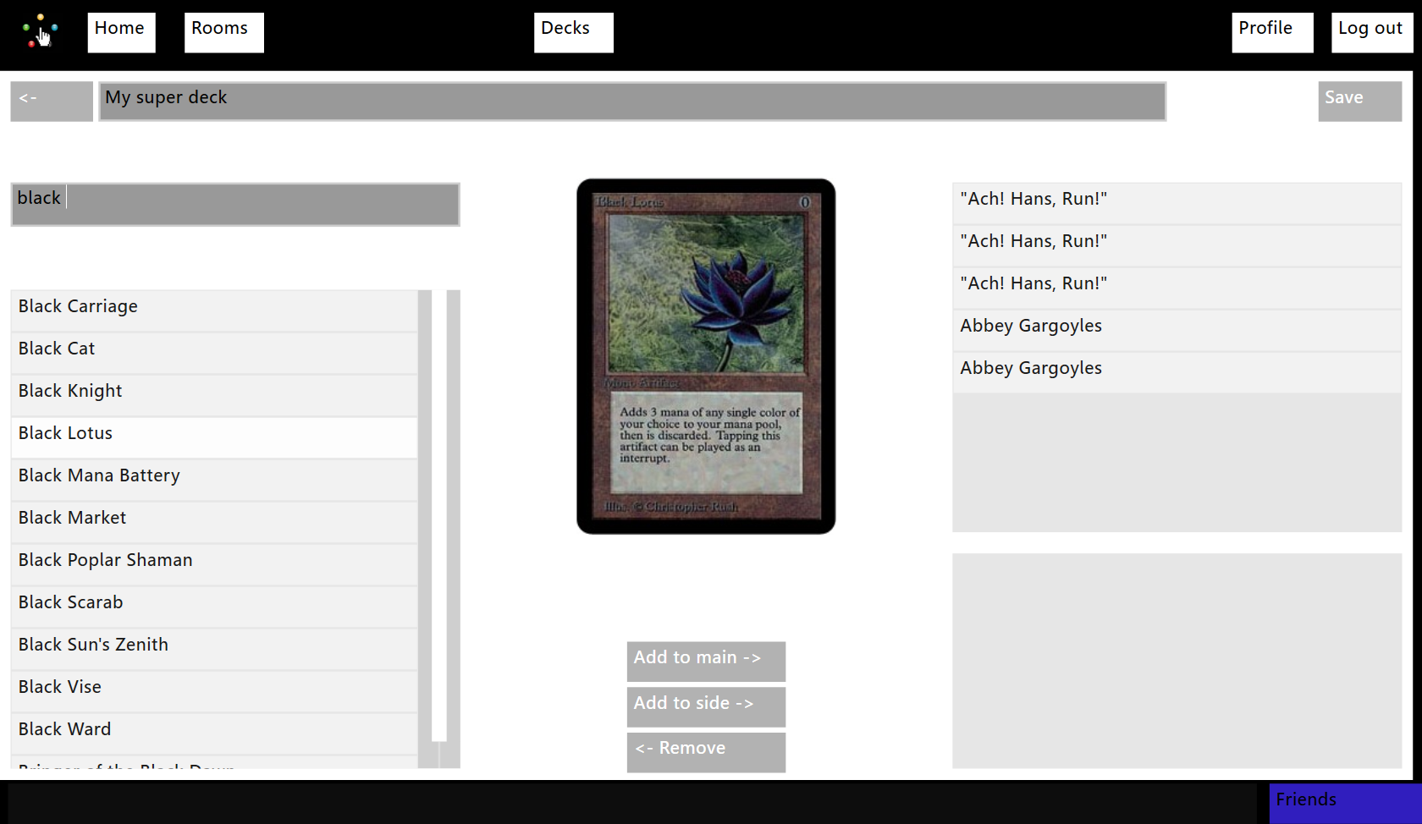

### Modify an existing deck

Through the deck interface click the edit button:

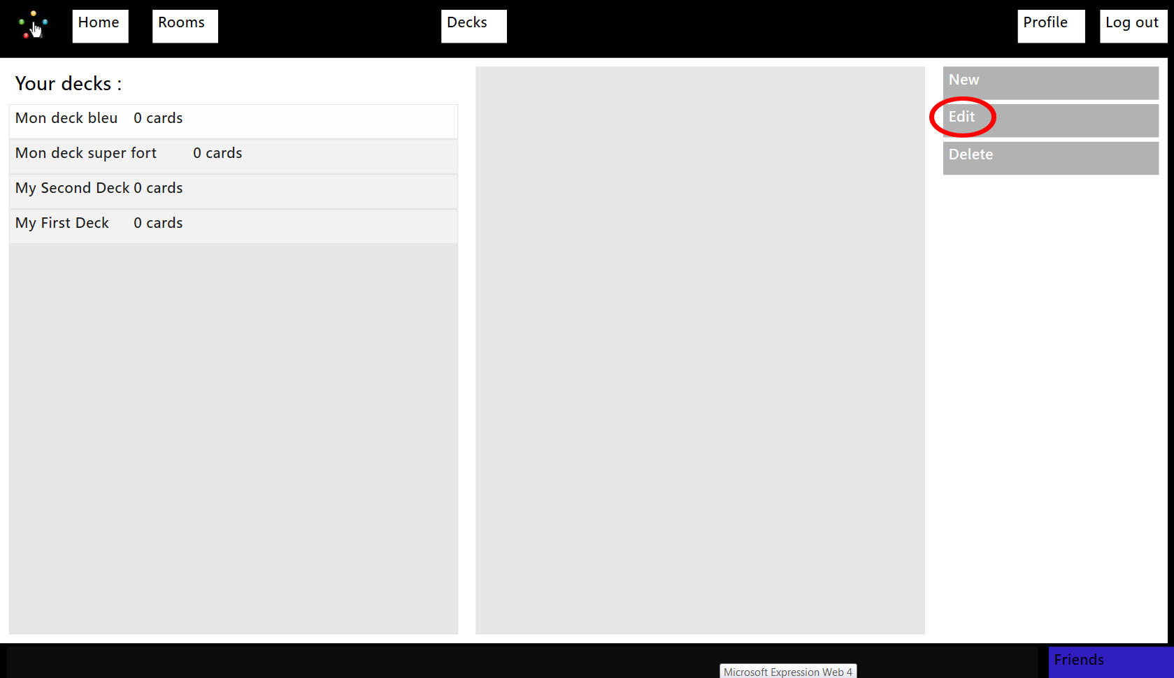

## Game

### Message an opponent

To message an opponent the user needs to write his message on the chat available on the side. After, click on **Enter** to send it.

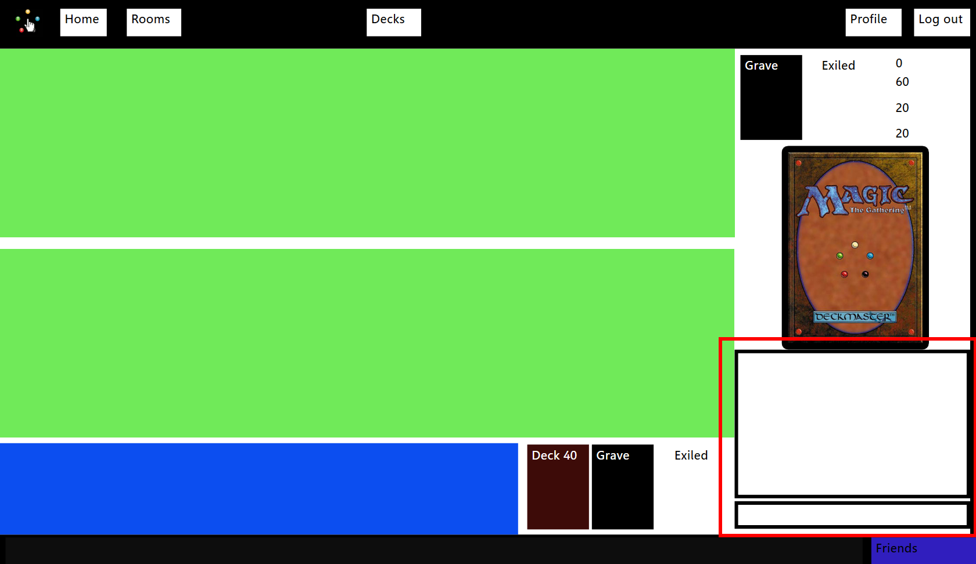

### Move cards

To move a card the user has to drag and drop the card until the wished destination spot.

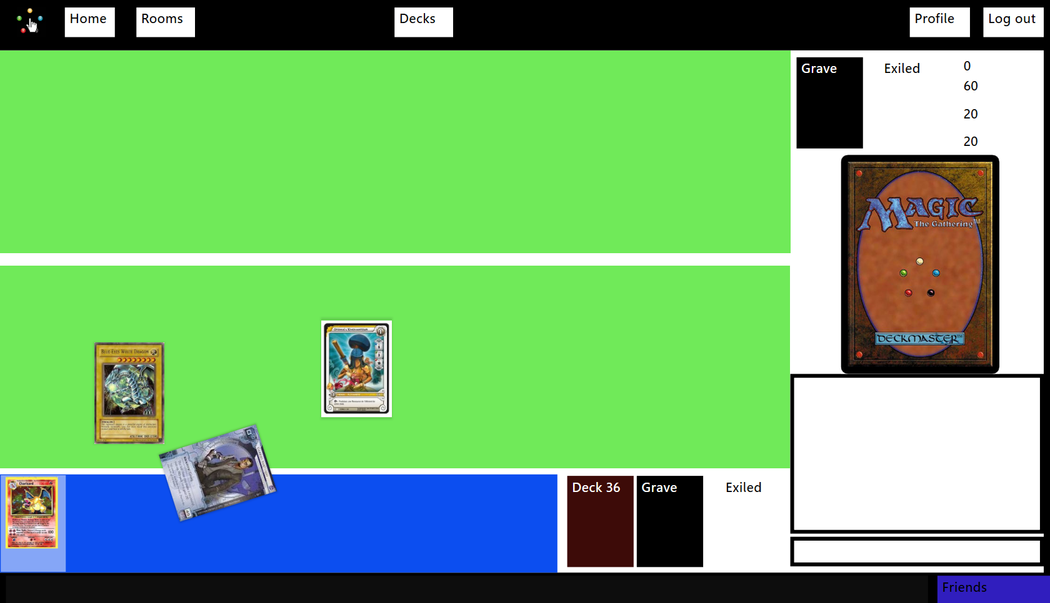

# Contact

To stay up to date about Magic Tactil follow these links:

Facebook: <https://www.facebook.com/pages/Magictactil/319882788114639>

Twitter: <https://twitter.com/MagicTactil>

Website: <http://eip.epitech.eu/2014/magictactil/about_fr.html>

For more information about the game Magic you can look into the explanations of the official website thanks to this link:

Game booklet:

<http://www.wizards.com/Magic/TCG/NewtoMagic.aspx?x=mtg/tcg/newtomagic/whatismagic>